We have dates available in May 2018
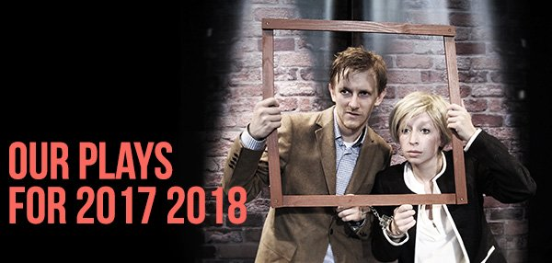
ETC: English Theatre Company is a professional touring theatre company; with 25 years experience offering original English language plays to students of English of all ages and levels: for primary; secondary; high school and adult learners.
Our educational plays, specifically written for the appropriate age and level of each audience, are enjoyable, interactive and involving so that students like them and carefully devised, through our team's extensive experience, to be pedagogically valid so that teachers find the experience worthwhile.
Our actors are all professional native speakers, our performances are entirely in English and we perform during school time; both in schools and local theatres.
The four plays we offer this academic year 2017 2018 are:
"THE CURIOUS ADVENTURES OF JACK TODD” – For beginners and lower level students. Suitable for Primary school learners.
"REWIND” – For lower level students. Suitable for older Primary and younger Secondary school learners.
"BACKCHAT”– For intermediate and higher intermediate students. Suitable for Secondary and High school learners.
"A BIT OF A HITCH”- For higher intermediate and advanced students. Suitable for High school and Adult learners.
Our prices are:
One performance: 785€
Two performances on the same day: 645€ per performance
Three or more performances on the same day: 525 € per performance
If you wish to receive more information about the company, our plays or tour dates please get in touch with us at: info@englishtheatrecompany.com
For further information have a look at our website: www.englishtheatrecompany.com
Thank you for your time and our very best wishes,
Michael Harry
Director ETC

